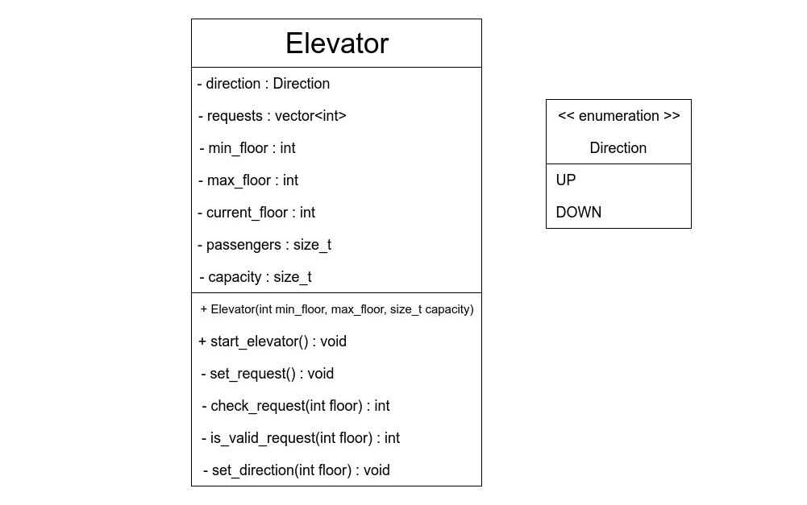

(-) means the attributes and methods are private. (+) means the attributes and methods are public.

Direction is the enum data type which can take the one of the two values (UP, DOWN). direction is the enum variable.

requests is an integer vector which store the requests entered by passengers. min_floor and max_floor store the minimum floor and maximum floor in the building respectively.

current_floor stores the floor at which the elevator is currently. Initially it is 0 that means the elevator is at ground floor.

passengers store the current number of passengers in the elevator. Initially it is 0.

capacity stores the maximum number of people the elevator can carry.